Assessment

Assessment-1:

Steps for the Result:

The image addresses are taken from google. We need to copy 5 animal image URLs and have to create an excel sheet with those and have to save the excel. We have to export the excel sheet data into Power BI. After that, we need to transform the data and we have to go to the AI insights tab and use vision analytics, we need to select the tab images table in the vision tab. After loading that we have to remove duplicates, and unneeded columns and have to change the data type of tab images confidence into the percentage and have to find out the average aggregations. After that click on the close and apply tab. So that the changes can be applied to the main tab of Power BI. There we have to go to the table view and click on the image URL column and in the column tools tab, we need to change the data category from uncategorized to Image URL. So that the URL converts and is shown as an image.

My opinion:

In my opinion, it is giving perfect results for images and displays and differs the image tabs perfectly. This is operating perfectly. This is feature is used for the conversion of image URL to image display. I have displayed the 5 animals and it displayed whatever is shown in the image. It pulls the words from the images clearly.

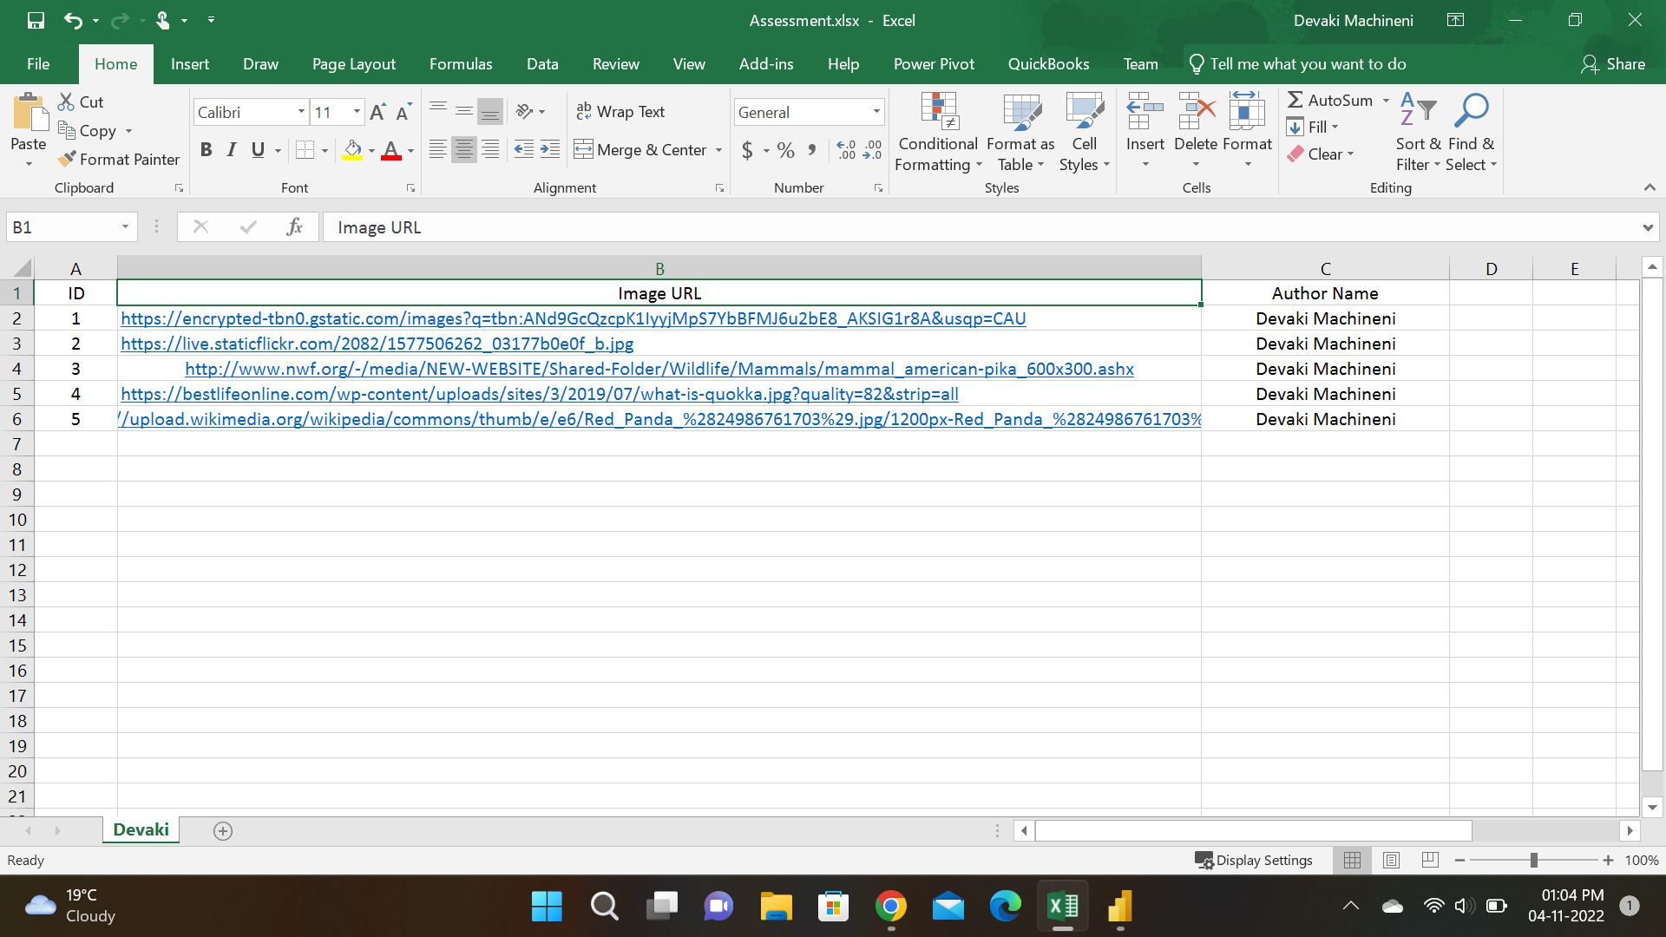

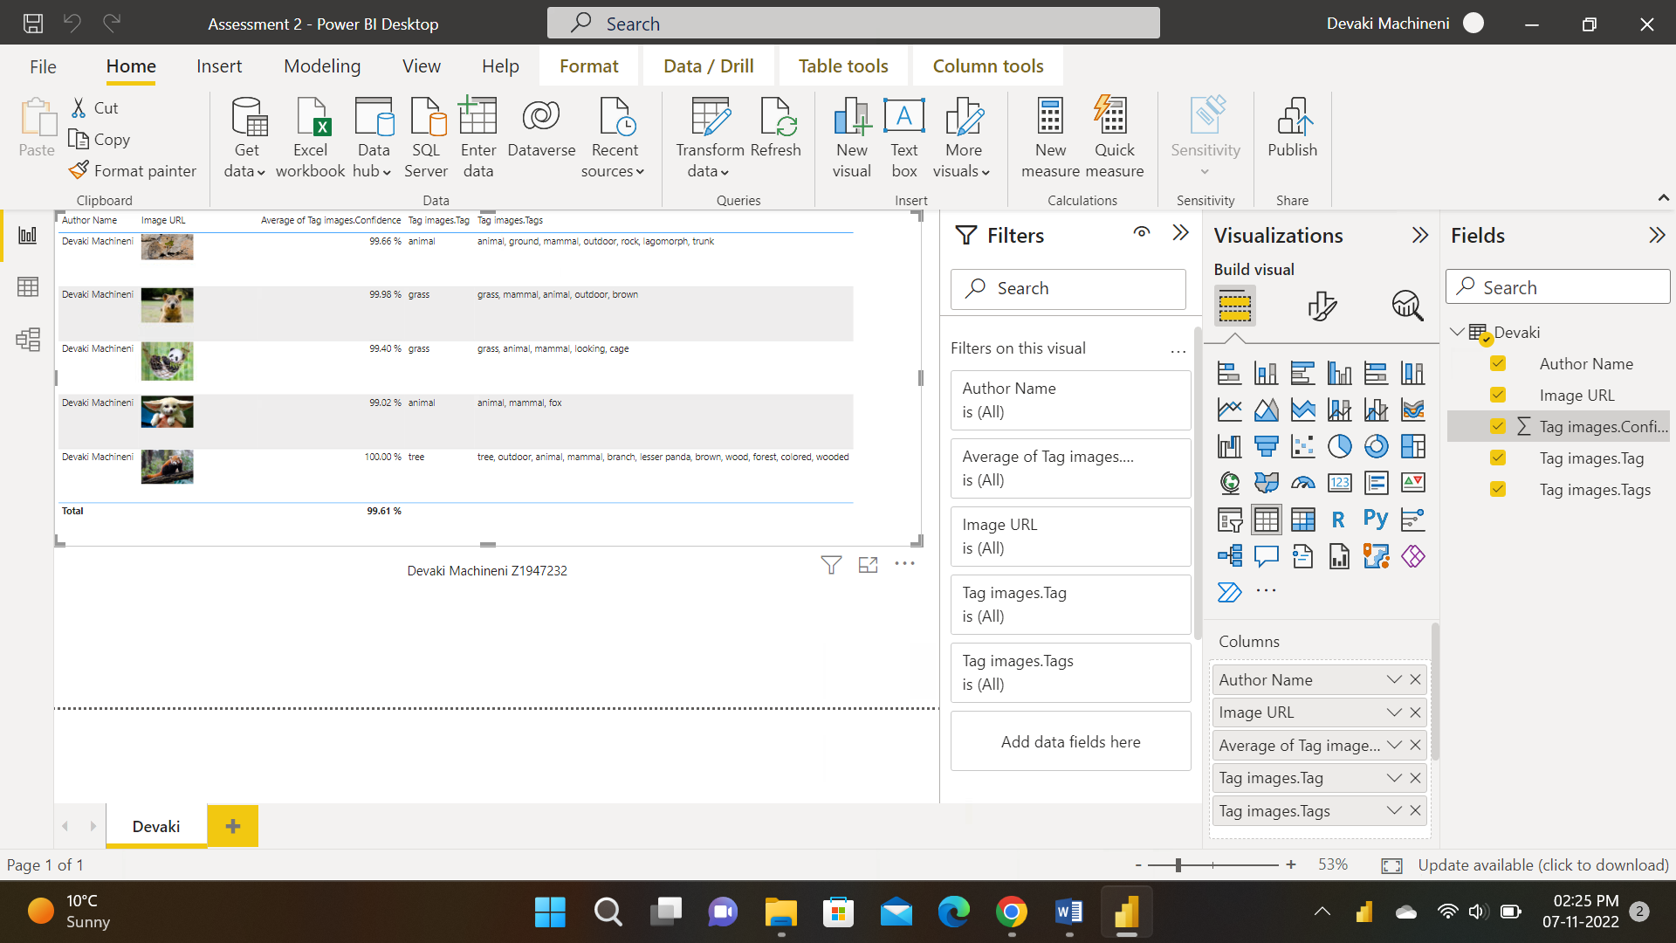

Assessment-2:

Step for the Result:

In excel 2016, we need to import the data by using the SQL server omissql.niunt.niu.edu, in that we need to take WideWorldImportersDW data and has to take the Dimension.City table. We need to import these data to power pivot by using the PowerPivot tab and clicking on manage. This will be directed to the Powerpivot. In the PowerPivot, we need to add the column of the population range and population sorting by using the formulas.

After creating those columns we need to click on any of the empty row or column and need to create a population count by using the below formula.

Population Count=DISTINCTCOUNT(City[Latest Recorded Population])

After that to find out the Population count between 8500 and 11199 we need to create another column for the population count by using the below formula as mentioned in the screenshot.

Population Count between 8500-11199=CALCULATE(DISTINCT COUNT(City[Latest Recorded Population]),City[population Range]="Between 8,500 and 11,199")

We need to sort the columns of population range and population sorting by using the tab sort by column. We need to create a pivot table by using these data and check the population range in the rows of excel and the sum of the population count into the values. We need to sort the population range into ascending order. And present the results with screenshots. In the below screenshots, we can see the population count of 8500 and 11199 is 655.

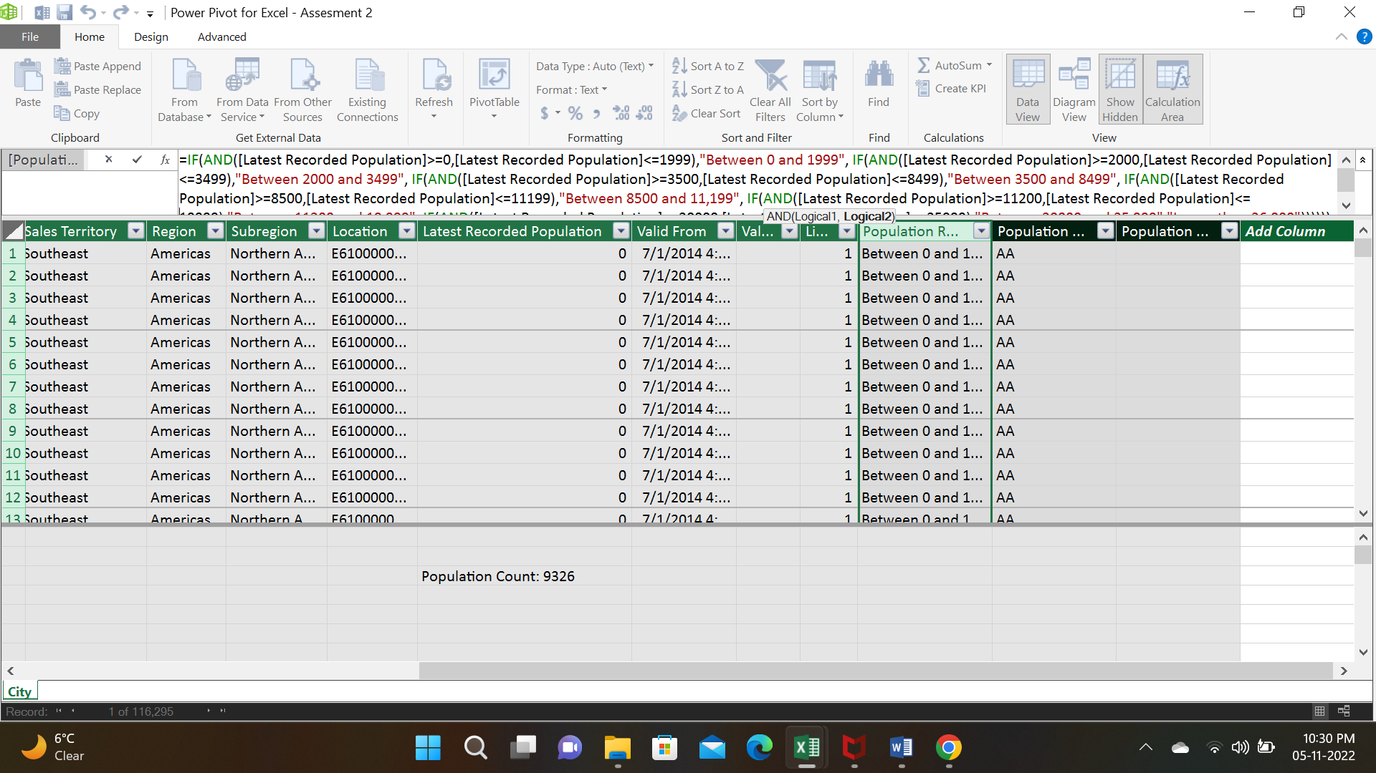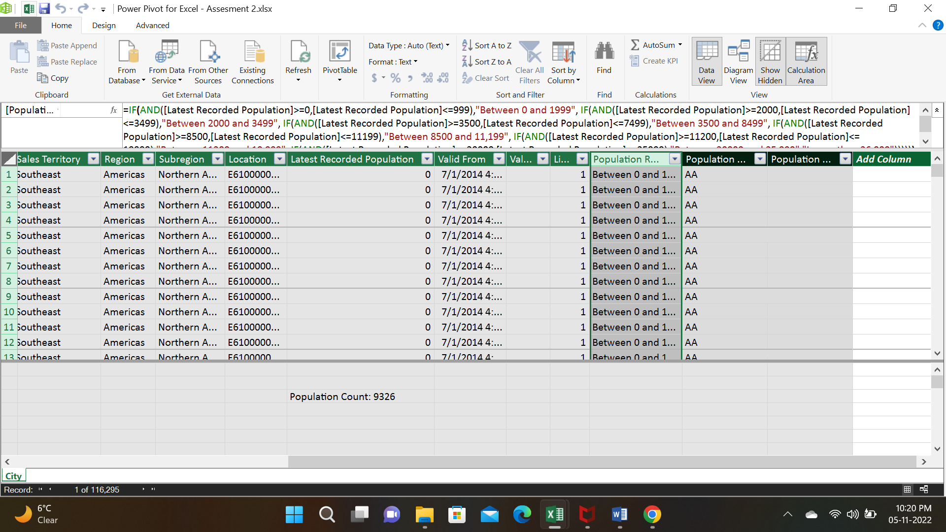

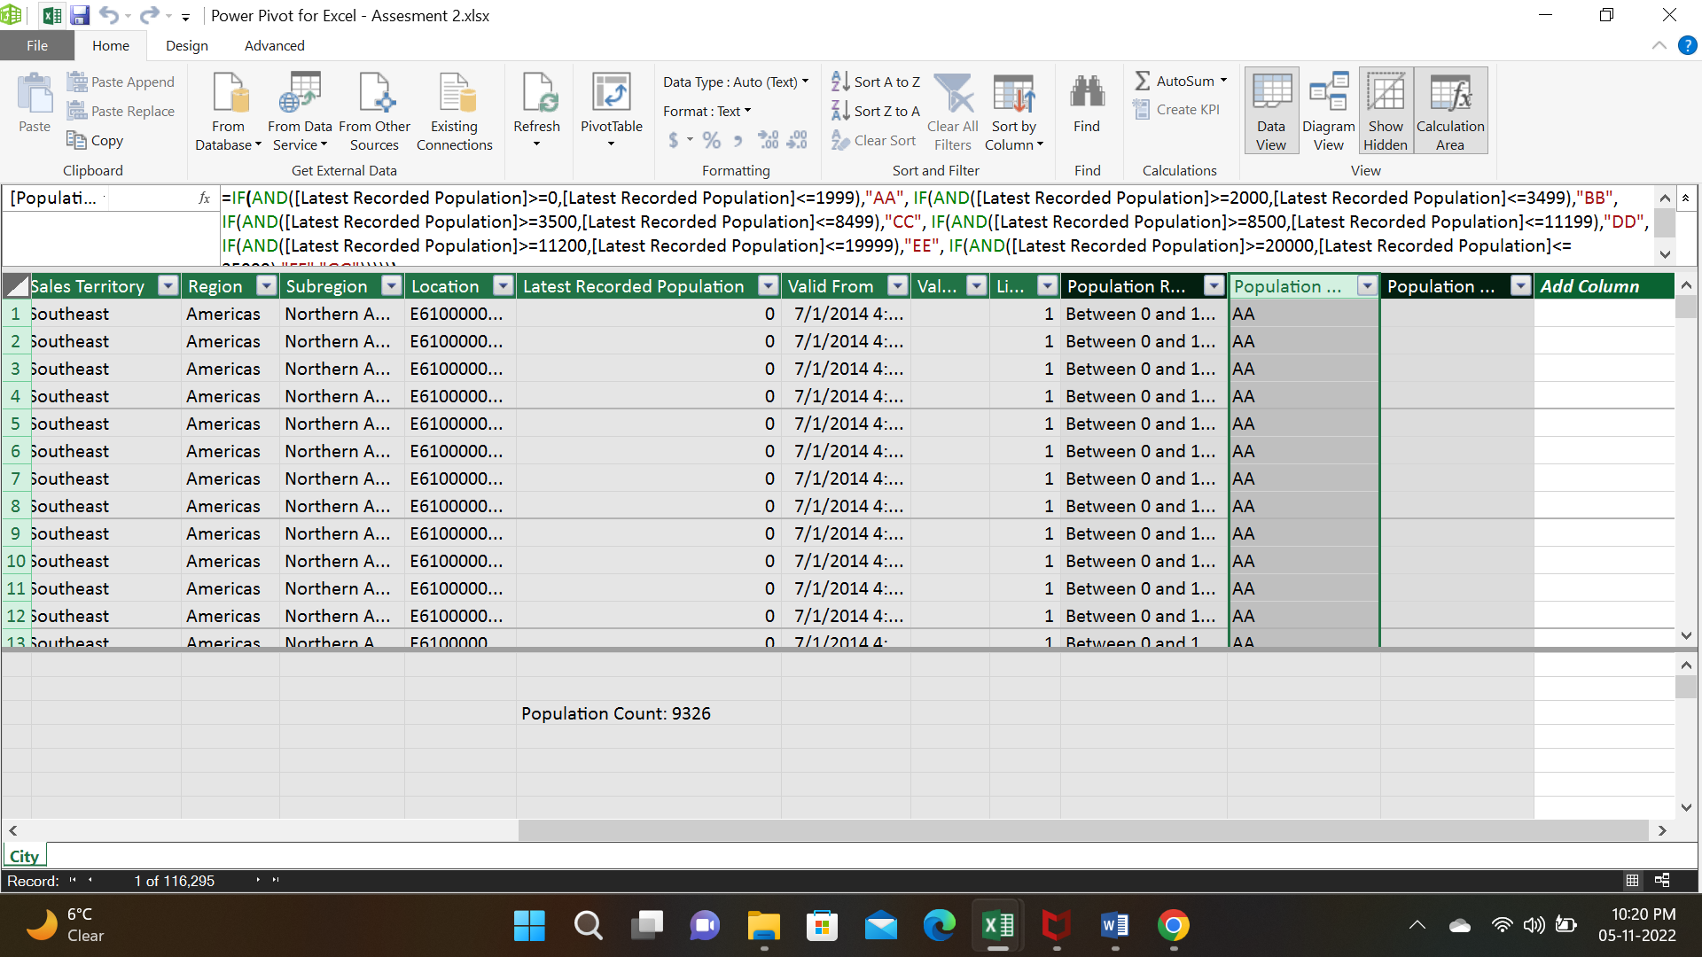

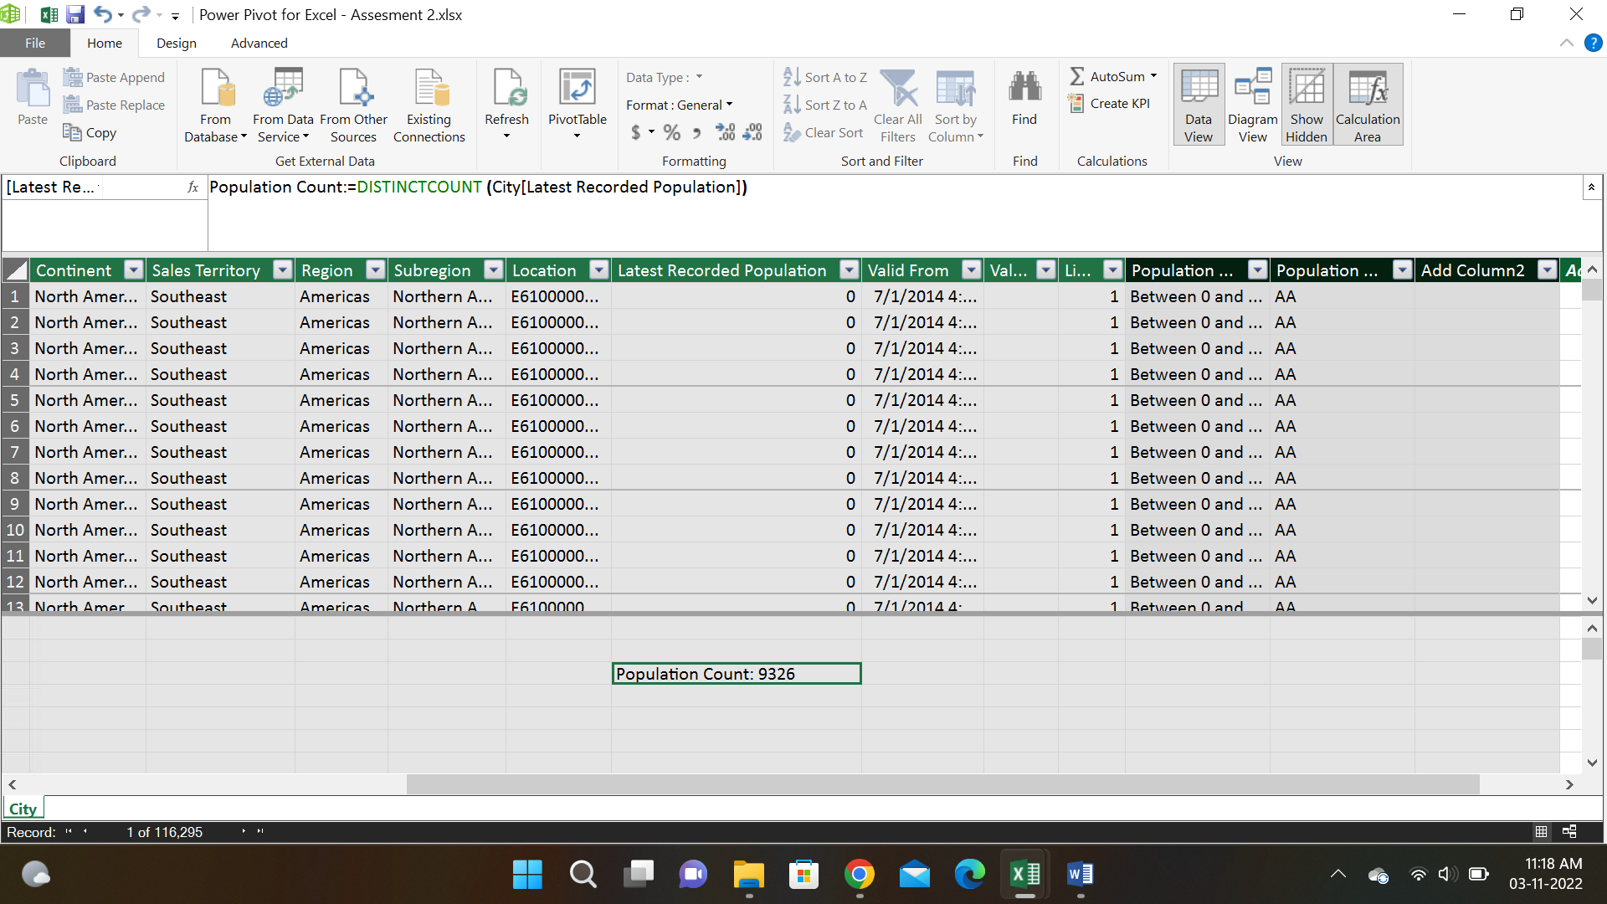

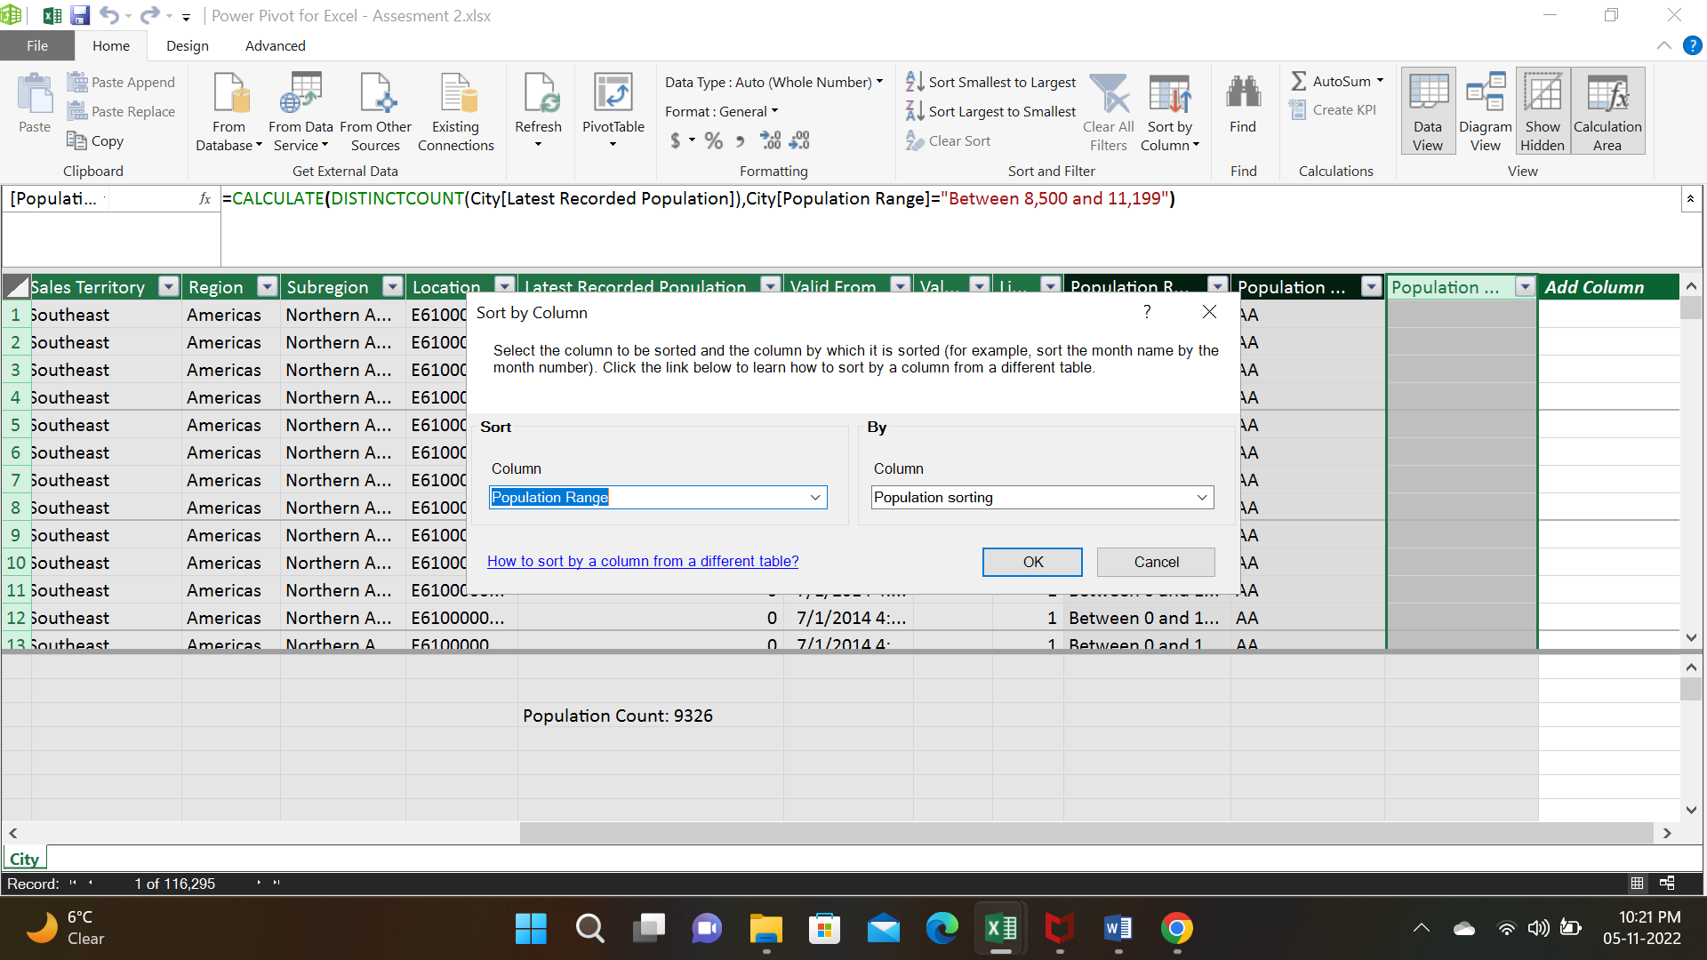

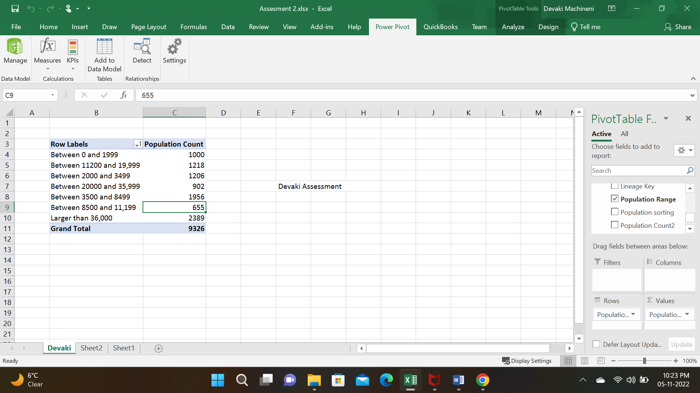

THE END